BROAD AGENCY ANNOUCEMENT DAY 2024
November 14, 2024

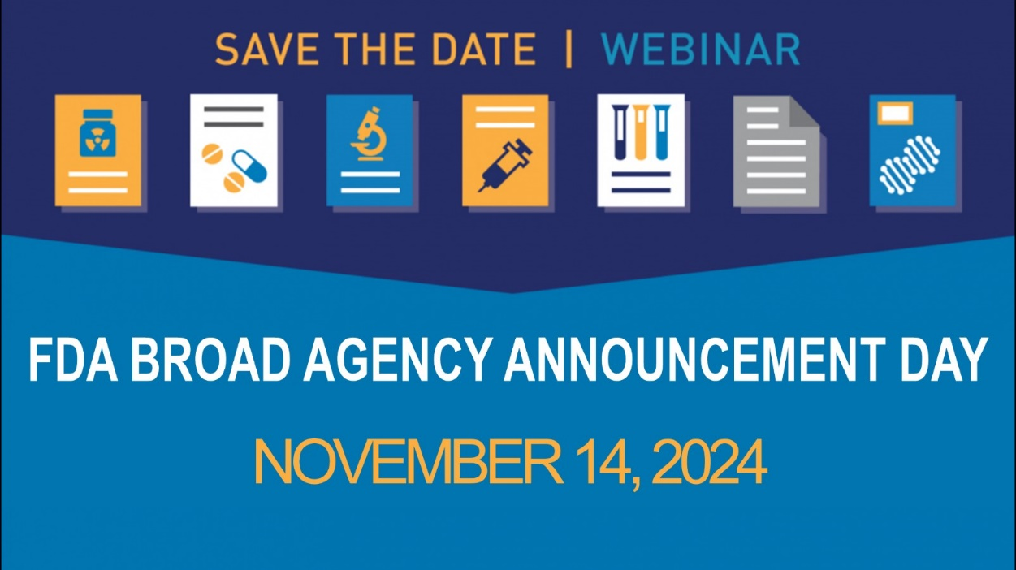

Please Save the Date for the 2024 FDA Broad Agency Announcement Day!
FDA funds extramural research through an agency-wide Broad Agency Announcement (BAA) for research and development to support regulatory science and innovation. Join us to learn more about the Fiscal Year (FY) 2025 BAA, and how to apply visit 2024 FDA Broad Agency Announcement Day

Intended audience
The FDA BAA is open to all responsible sources, and small businesses are strongly encouraged to respond. Offerors may include single entities or teams from private sector organizations, Federally Funded Research and Development Centers (FFRDCs), and academic institutions.

Register
Please register in advance and feel free to share information with anyone interested.

Submission Deadlines
Please note that these are deadlines for FY 2025 funding considerations.
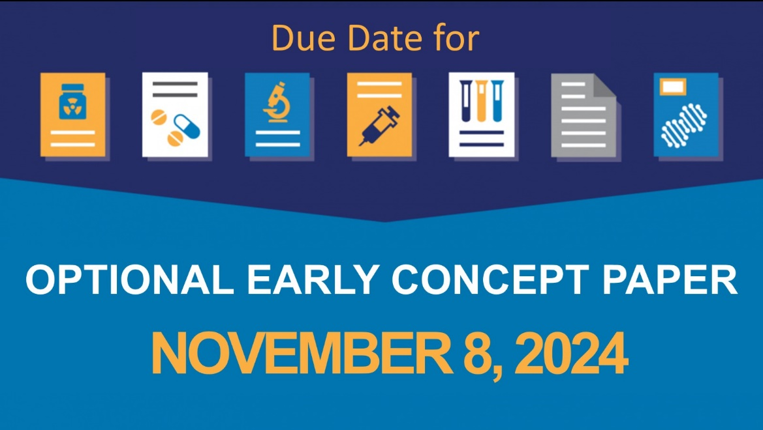

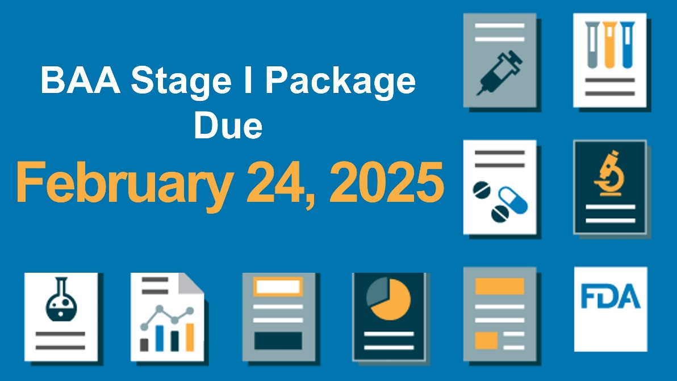

Contact us / submit a question
Please contact FDABAA@fda.hhs.gov with questions, including any questions you'd like us to answer at this event.

Thank you,
The FDA BAA Team

Information for Previous events
2023 FDA Broad Agency Announcement Day
2022 FDA Broad Agency Announcement Day

