KENTUCKY DEPARTMENT FOR PUBLIC HEALTH & University of Kentucky Veterinary Diagnostic Laboratory EPIDEMIOLOGY
Rabies Surveillance in Kentucky
A 37-year analysis of animal specimen testing, geographic distribution, and seasonal patterns · 1989–2026

REPORT DATE  May 22, 2026 | DATA SOURCE  KY Rabies Testing DB | RECORDS ANALYZED  39,967 specimens | COVERAGE  All 120 KY counties

39,967  TOTAL SPECIMENS | 935  POSITIVE CASES | 2.3%  POSITIVE RATE | 1989  PEAK YEAR (135)

Executive Summary
This report synthesizes 37 years of animal rabies testing data collected by the Kentucky Department for Public Health. Between 1989 and May 2026, 39,967 animal specimens were submitted for rabies testing across all 120 Kentucky counties, yielding 935 confirmed positive cases — an overall positivity rate of 2.3%.
Surveillance activity and positive case counts have changed substantially over time. A major outbreak peak in 1989 recorded 135 positives in a single year. Since then, annual counts have stabilized at 10–26 positives per year, suggesting improved population-level immunity and more consistent exposure management.
The data reveal two distinct risk windows: a spring peak in positivity rate (March–April, ~3.1%) driven by post-hibernation wildlife activity, and a summer peak in raw case volume (August, 129 cases historically) driven by elevated human-wildlife contact.
Geographically, Fayette County (Lexington) accounts for the highest burden with 114 confirmed positives — more than twice the next-highest county. Central Bluegrass counties (Woodford, Madison, Scott, Mercer, Jessamine) form a consistent high-risk cluster.

Key Findings

1 | Declining trend since 1989. Annual positive cases peaked at 135 in 1989 and have since stabilized at 10–26 per year. However, 2024–2025 show the highest recent counts (23 and 26 respectively), warranting continued monitoring.

2 | Stable positivity rate. Despite fluctuating testing volumes, the positive rate has held steady at approximately 2% since 2010, suggesting consistent surveillance coverage rather than a growing epidemic.

3 | Fayette County is a persistent hotspot. With 114 confirmed cases, Fayette accounts for 12.2% of all positives. The Central Bluegrass corridor (Scott, Madison, Woodford, Mercer, Jessamine) collectively accounts for nearly one-third of all statewide positives.

4 | Two distinct seasonal windows. March–April has the highest positivity rate (3.1–3.0%). August has the highest raw case count (129 total). December is the quietest month (30 cases, 1.3% rate).

5 | Summer peak is most consistent. The June–August cluster is the most reliably recurring seasonal pattern. Spring spikes are more variable year to year.

6 | Data quality consideration. Approximately 12% of records are missing an exposure type field, and 10 records have no county assignment. These gaps should be addressed in future data collection.

Temporal Trends
Annual testing volumes and positive case counts over the 37-year study period reveal clear phases: a high-activity outbreak period in the late 1980s through mid-1990s, a sustained decline through the 2000s, and a relatively stable modern surveillance era from 2010 onward.
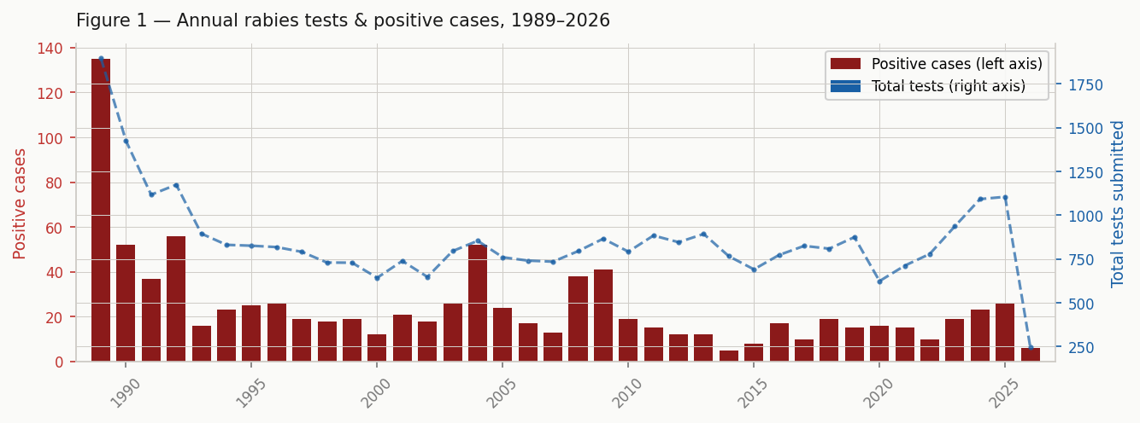
Figure 1. Bars represent positive cases (left axis); dashed line represents total tests submitted (right axis). 2026 is partial-year data as of May 22.

Notable: The 2024–2025 uptick (23 and 26 positives respectively) represents the highest consecutive two-year totals since 2008–2009. Testing volume has also increased, so the positivity rate remains near the historical average — but the absolute case counts merit attention.

Geographic Distribution
Positive rabies cases are not uniformly distributed across Kentucky. The Central Bluegrass region — particularly Fayette, Scott, Madison, Woodford, Mercer, and Jessamine counties — accounts for a disproportionate share of confirmed positives. This cluster likely reflects favorable wildlife habitat (forest edges, creek corridors), high domestic animal density, and robust testing infrastructure.
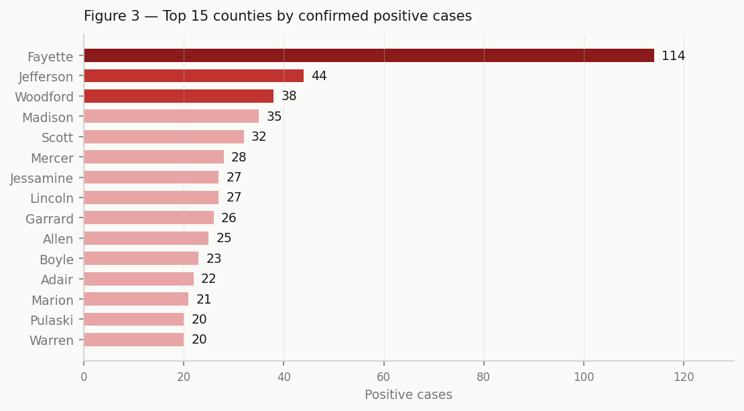
Figure 2. Top 15 Kentucky counties by confirmed positive cases, all years combined (1989–2026).

Central Bluegrass Cluster: The five-county cluster (Fayette, Scott, Madison, Woodford, Jessamine) collectively accounts for 266 confirmed positives — 28.5% of all positives statewide — despite covering a modest geographic footprint.

Eastern Kentucky Note: Eastern Kentucky counties (Floyd, Pike, Harlan, Knox) show lower positive counts despite substantial wildlife habitat, which may reflect lower testing submission rates rather than true lower prevalence.

Seasonal Patterns
Analysis of the full 37-year dataset reveals pronounced seasonal variation in both the volume and rate of positive detections. Two distinct risk windows emerge, each driven by different ecological mechanisms.
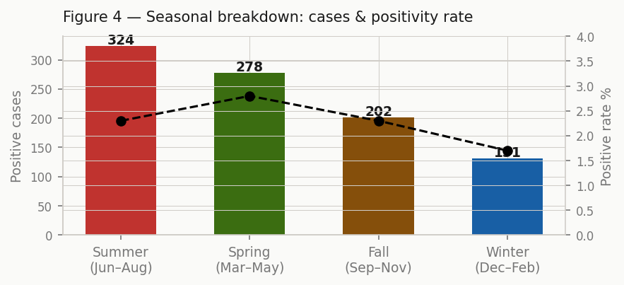
Figure 3. Seasonal breakdown: Summer has the highest case count (324); Spring has the highest positivity rate (2.8%). Winter is the quietest season on both measures.

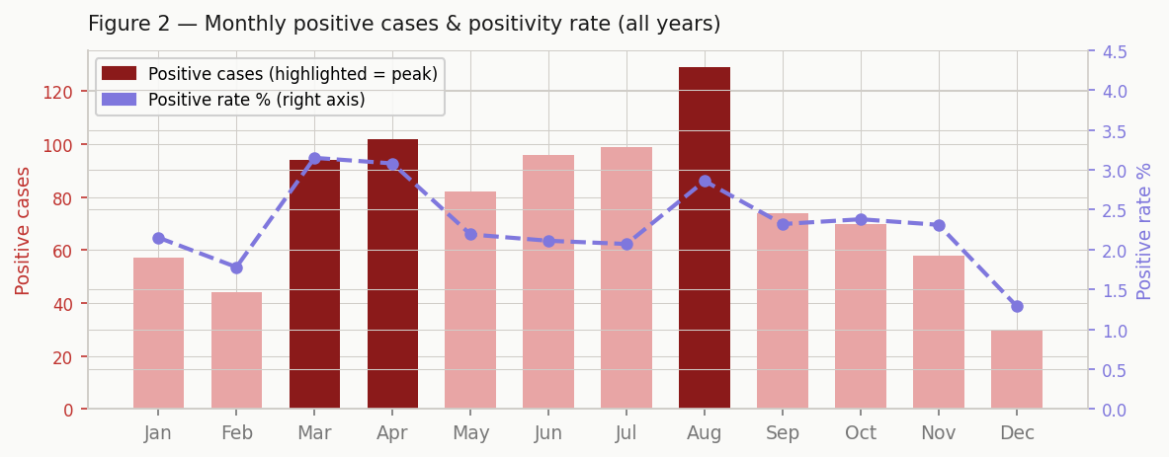
Figure 4. Monthly positive cases and positivity rate (all years combined). August peaks in raw cases (129); March peaks in positivity rate (3.15%). December is the quietest month.

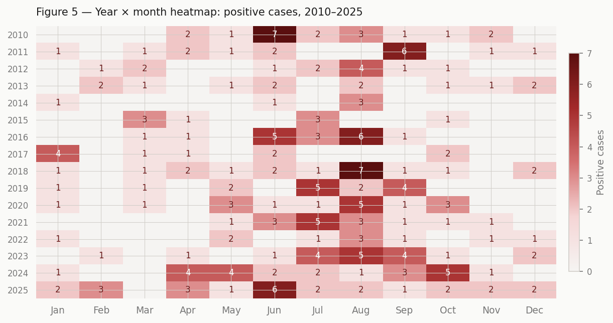
Figure 5. Year × month heatmap of positive cases, 2010–2025. Each cell shows case count for that month/year. Darker red = more cases. The June–August cluster is the most consistently recurring pattern.

The year-by-month heatmap confirms that the summer peak (June–August) is the most reliable seasonal signal in the data. High-intensity cells (5+ cases in a single month) cluster almost exclusively in the summer period. By contrast, the spring peak in positivity rate reflects a period when fewer tests are submitted, so a moderate number of positives translates to an elevated rate.

Public Health Implications

Spring window (March–April): Although absolute case counts are lower, the elevated positivity rate (3.1%) suggests animals tested during this period are more likely to be positive. Enhanced post-exposure prophylaxis (PEP) guidance and public awareness campaigns should be prioritized during late winter through early spring, coinciding with increased wildlife activity following hibernation.

Summer peak (June–August): The highest raw case volume occurs in summer. Outreach to veterinarians, animal control agencies, and the public about domestic animal vaccination and exposure reporting should be intensified ahead of the June–August period annually.

Central Bluegrass focus: The persistent geographic cluster centered on Fayette County warrants targeted interventions — including oral rabies vaccine (ORV) baiting programs, wildlife surveillance, and veterinary compliance monitoring — given the concentration of cases relative to other regions.

2024–2025 uptick: The recent elevation in case counts across two consecutive years should be monitored closely. If the trend continues into 2026, a formal outbreak investigation may be warranted.

Data Notes
This analysis is based on the Kentucky Rabies Database as of May 22, 2026, containing 39,967 specimen records spanning January 1989 through May 2026. The dataset includes fields for specimen ID, submission date, test result, exposure type, county, and state.
Data quality: Approximately 4,793 records (12.0%) are missing an exposure type classification. Ten records have no county assignment. The 2026 data represent a partial year (through May 22) and should not be used for annual rate comparisons.
Positivity rate calculation: Rates are calculated as confirmed positive tests divided by total tests submitted. All percentage figures are rounded to one decimal place.

